Warning – Adaptive Headlamps – CGEA1.3

Functional Description

The purpose of the Adaptive Headlamp display is to inform the driver of a failure in the vehicle’s exterior adaptive headlamps function.

The Adaptive Headlamp Warning function correlates the Adaptive_Hdlmp_Fault signal from the HCM and the operational mode to display the appropriate warning in the message center.

Interfaces

Interface Context Diagram (I/O Block Diagram)
Figure 1 Warning – Adaptive Headlamps Context Diagram
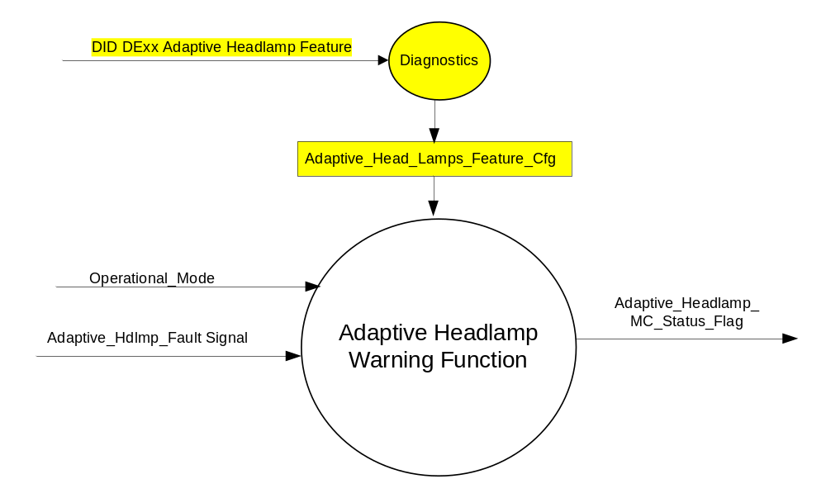

Inputs
      - INTERNAL:
            - Operational_Mode
            - Adaptive_Head_Lamps_Feature_Cfg
- MUX message from the CAN bus

- Adaptive_Hdlmp_Fault Signal
Signal Name | Size  (bits) | Pos.  (bits) | Detail | Units | Res. | Offset | State  Encoded | Min | Max
Adaptive_Hdlmp_Fault | 1 | 38 |  | SED | 1 | 0 |  | 0 (0x0) | 1 (0x1)
 |  |  | No |  |  |  | 0x0
 |  |  | Yes |  |  |  | 0x1

Outputs
Adaptive_Headlamp_MC_Status_Flag that is used to control the Warning displayed in the message center.

Function/Performance

Operational Modes

Mode | Differentiating Vehicle Conditions
Sleep Mode | OFF
Limited Mode | OFF
Normal Mode | Adaptive Headlamp Warning Function Text Messages ON / OFF
Crank Mode | Adaptive Headlamp Warning Function Text Messages ON / OFF

The above table references the setting of the Warning flag as per this section. However, the actual Warning display operational modes are displayed in the Message Center section of this SPSS.

Voltage Levels

Refer to the Cluster Features Table located in the Operational Modes and Voltage Range Strategies Section of this SPSS

Human-Machine Interface

Visual

Indicator Graphics / Display Format

Refer to Message Center Function description reference "BEF Display 2x14 Text Message List.xls" file Message ID W540

1.3.3.1.2 Indicator Color Coordinates

Reference section COLOR & ILLUMINATION REQUIREMENTS (GRAPHICS)

1.3.3.1.3 Indicator Characteristics

Refer to Message Center X Display_Y Button Interface Section, where X and Y are appropriate values in this document.

Audio

No Message Center Warning Chime is associated with this Warning.

Switch Control Logic

Consumer access to Adaptive Headlamps Warning shall be as specified in the message center basic functionality display as specified in Message Center X Display_Y Button Interface Section, where X and Y are appropriate values in this document.

System Accuracy

Within 100 msec of receiving a message that results in a change of state the cluster will update the display to the proper state.

Operation: Performance and Functional

Subsystem Algorithm Flowchart / State Diagram

- State Matrix for Warning – Adaptive Headlamps
Operational_Mode | Adaptive_Head_Lamps_  Feature_Cfg | Adaptive_Hdlmp_Fault Signal | Adaptive_  Headlamp_ MC_Status_Flag
Normal or Crank | Enabled (0x1) | Yes (0x1) | ACTIVE
Normal or Crank | Enabled (0x1) | Missing as per 1.4.1 | ACTIVE
All Other Cases |  |  | INACTIVE

Operation Description (supports algorithm flowchart /state diagram)

- For definition of how the Message Center arbitrates and displays Active warnings, see the Warning / Alert Display Logic Diagram, located in the Message Center – X Display with W Button Interface section of this SPSS (where X and W are appropriate values in this document). W540 will be the text used by the Message Center when it displays this ACTIVE Warning.
- This system's "OK" status is NOT reported in the Message Center SYSTEM CHECK.

Function Safety Classification (EMC)

Class B

Memory Storage

Parameter Name | Description | Value at  Battery Connect | Value at  Module Wake-up
Adaptive_Headlamp_MC_Status_Flag | Used to control the state of the warning to the Message Center arbitrator | INACTIVE (0x0) | INACTIVE (0x0)
Adaptive_Head_Lamps_Feature_Cfg | Configures cluster to allow Adaptive Headlamp Warning and also set missing messag DTC for HCM (set to disable at cluster end of line) | Use Stored Value | Use Stored Value
Adaptive_Hdlmp_Fault Signal | Input signal sent from the HCM to the IC | No (0x0) | No (0x0)
Operational_Mode | 4 state indicator for cluster operational mode | Limited | Limited or Normal or Crank

Prove Out

No.

Reconfigurable Telltale

No.

Message Center Msg

Refer to Message Center Function description reference "BEF Display 2x14 Text Message List.xls" file Message ID W540

Error Handling

Missing Message/Undefined Data Strategy

None.

The signals will be declared missing as per the Diagnostics section of this SPSS.

DTCs states and history will be determined as per the Diagnostics section of this SPSS.

If the Adaptive_Head_Lamps_Feature_Cfg is DISABLED, the cluster shall never log a missing message DTC due to this feature.

Diagnostics

Self Test

None

Engineering Test Mode

Reference section “Dealer / Engineering Test Mode (ETM)”

Part II Performance

Supported Diagnostic Trouble Codes (DTCs)
DTC | Description
C24100 | Lost Communication With Headlamp Control Module (HCM)

Mod Conf (DID DExx)
Block  Num | Block Description | Byte(s) | Bits | State: Description | "0" | "1" | Default | Comments/Information
PACKETED BLOCKS
$xx | Option Content (B&A) | * | * | Adaptive  Headlamps Feature | Disabled | Enabled | Disabled | Set to Enabled when HCM present (vehicle has Adaptive Headlamps). This enables Fault warning and missing message DTC.  This config needs to be Eanbled before enabling menu choice configs:  Adaptive_Head_Lamps_Cfg  Adaptive_Head_Lamps_Traffic_Cfg  Set to Disabled when HCM module not present (Feature not present)
*Byte and bit location to be identified in Part II Specification for this cluster

Reference Specification

IS-0001 WARNINGS/INDICATORS/DISPLAYS PROVEOUT
IS-0052 OPERATING VOLTAGES - FUNCTIONAL/PERFORMANCE
IS-0069 FUNCTIONAL IMPORTANCE CLASS
IS-0324 WINDSHIELD & OTHER REFLECTIONS
IS-0327 WARNING INDICATOR EVALUATION
IS-0379 NORTH AMERICAN WARNINGS AND INDICATORS STRATEGY

IL-0017 TELLTALE AND INTERIOR ILLUMINATION – COLOR AND INTENSITY
IL-0019 GENERAL ILLUMINATION DIMMING
IL-0021 CRAFTSMANSHIP – DISPLAYS
IL-0022 GENERAL ILLUMINTATION COLOR
IL-0023 CLARITY/LEGIBILITY/READABILITY/VISUAL CONTRAST
IL -0043 OPERATIONAL ENVIRONMENT FUNCTIONALITY
IL -0045 COLOR
IL -0047 TELLTALE, INDICATOR AND DISPLAY LIGHT INTENSITY
IL -0048 ILLUMINATION ACCEPTABILITY

03-0661 PLACEMENT: CONTROL AND DISPLAY LOCATIONS
03-0662 PLACEMENT: LOGICAL GROUPING FUNCTION AND USAGE
03-0664 PLACEMENT: DOWN VISION TO COMPONENTS WITH HIGH VISUAL DEMAND
03-0665 PLACEMENT: EXPECTED LOCATIONS OF CONTROLS AND DISPLAYS VDS
03-0670 INTERIOR VISIBILITY
03-0671 INTERIOR VISIBILITY: REFLECTIONS FROM COMPONENTS & SURFACES
03-0672 INTERIOR VISIBILITY: REFLECTIONS IN DISPLAYS
03-0673 INTERIOR VISIBILITY: VISUAL OBSCURATIONS
03-0674 INTERIOR VISIBILITY: ILLUMINATION CONTROLS / DISPLAYS
03-0675 INTERIOR VISIBILITY: VEILING GLARE
03-0677 INTERIOR VISIBILITY: SUNLIGHT WASHOUT
03-0681 IDENTIFICATION: CHARACTER AND SYMBOL SIZE
03-0682 IDENTIFICATION: LEGIBILITY
03-0685 IDENTIFICATION: SYMBOLS, ABBREV FOR CONTROL
03-0721 LOGIC OF OPERATION: OPERATIONAL STEREOTYPES
03-0722 LOGIC OF OPERATION: INTERPRETATION
03-0723 LOGIC OF OPERATION: USE OF SYSTEMS WITH VISUAL DISPLAYS

Revision History

SPSS Module Revision History

Revision Level | Name | Change Description | Date
1.0 | V. Patel | Updated for CGEA 1.3 based on CGEA STSS v1.0  Section 1.2.2 – Removed table referencing the HS-CAN message that contains the input signals.  Section 1.4 – Rewritten. Deleted references of specific missing message flags and timer.  Section 1.5.3 – Deleted DTC logging criteria from the table. | 4/13/2010
1.1 | S. Watkins | Changed signal from Adaptive_Headlamp_Failure to Adaptive_Hdlmp_Fault throughout. | 4/18/2011
2.0 | S. Watkins | A configuration issue was found on CD4.1E and CD4.2E. The DE00 config in this STSS was supposed to be separate from the 2 menu configs in STSS “Adaptive Head Lamps Control Function CGEA1.3”. However, instead of 3 separate configs, the first 2 were merged in the Global_Config, for a total of only 2 configs. This resulted in a system issue where you have an HCM, but need the menu turned off, that you lose the fault warning. The most painless solution is to delete the config from this STSS. Thus, anytime the HCM requests a warning, it is activated.  Updates:  - Deleted all references to Adaptive_Headlamp_Cfg  - Deleted DTC | 3/19/2015
3.0 | S. Watkins | Per Waldemar Weber and DI Change Control on 9/30/15, I am permanently correcting the changes from 2.0, and adding in a unique config for HCM. This will allow a missing message DTC to be set against the HCM as well as a warning display.  Thus, the 2 existing configs for menus are:  Adaptive_Head_Lamps_Cfg  Adaptive_Head_Lamps_Traffic_Cfg  I am adding a new config for HCM present:  Adaptive_Head_Lamps_Feature_Cfg  Updates:  - Replaced “Adaptive_Headlamp_Cfg” with “Adaptive_Head_Lamps_Feature_Cfg” throughout document.  - Removed all “strikethroughs” from version 2.0. | 10/26/2015
4.0 | S. Watkins | Waldemar Weber found a defect in the truth table. The missing message case should make the warning ACTIVE.  - Updated missing message row in Table 1.1. | 10/27/2015

